**Projectile Motion**

We must separate a projectile’s motion into horizontal and vertical components first.

Consider a soccer ball kicked with a velocity “u” at an angle θ to the ground.

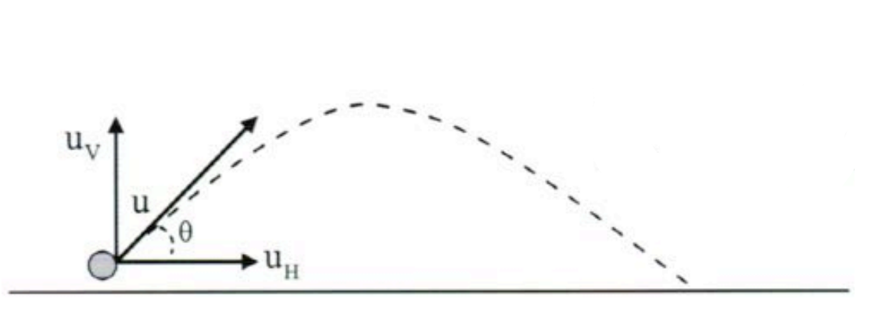

Projectile’s initial vertical velocity: uv = u sinθ

Projectile’s initial horizontal velocity: uh = u sinθ

Maximum height reached:

$$v^{2}={u_{v}}^{2}+2gs$$

$$0^{2}=(u sinθ)^{2}+2gs_{v}$$

$$s_{v}=\frac{(u sinθ)^{2}}{2g}$$

Time of flight:

$$0=u_{v}+gt$$

$$0=u sinθ+gt$$

$$t_{from start to middle}=\frac{u sinθ}{g}$$

$$t=\frac{2u sinθ}{g}$$

Note: If the projectile begins its path from max height (e.g., a cliff) don’t multiply by 2.

Or:

$$s_{v}=u_{v}t+\frac{1}{2}at^{2}$$

$$0=u_{v}t+\frac{1}{2}at^{2}$$

$$u_{v}t=\frac{1}{2}gt^{2}$$

$${2u}_{v}=gt$$

$$2usinθ=gt$$

$$t=\frac{2usinθ}{g}$$

Height:

$$s_{h}=(u cosθ)t$$

$$t=\frac{s_{h}}{u cosθ}$$

$$s_{v}=u_{v}t+\frac{1}{2}at^{2}=$$

$$u sinθ \left(\frac{s_{h}}{u cosθ}\right)+\frac{1}{2}at^{2}=$$

$$s_{h} tanθ+\frac{1}{2}at^{2}$$

Range:

$$t=\frac{2u_{v}}{g}=\frac{s_{h}}{u_{h}}$$

$$2u_{v}u_{h}=s_{h}g$$

$$2usinθucosθ=s_{h}g=$$

$$u^{2}2sinθcosθ=s_{h}g=$$

$$u^{2}sin2θ=s_{h}g$$

$$s_{h}=\frac{u^{2}sin2θ}{g}$$

Gravitational acceleration doesn’t affect the horizontal motion of the projectile.

Time of flight is the same whether we consider the projectile’s horizontal or vertical motion component.

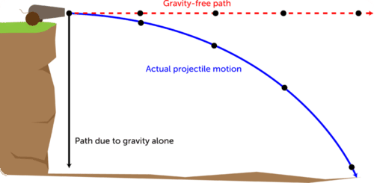

If we take into account air resistance, the actual values for height, time of flight and range will all be less than those previously stated and the flight path of the projectile will also change, decreasing the horizontal range.

Vertical motion – The body is under the influence of gravity with a constant downward acceleration of 9.8ms-2. This can be used to determine the time of flight and maximum height.

Horizontal motion – Assumed to be constant during the flight of the projectile. This can be used to find the range of flight.

Effects of air resistance on the projectile’s path:

* Reduce its calculated range.
* Reduce its calculated maximum height.
* Increase its angle of descent.

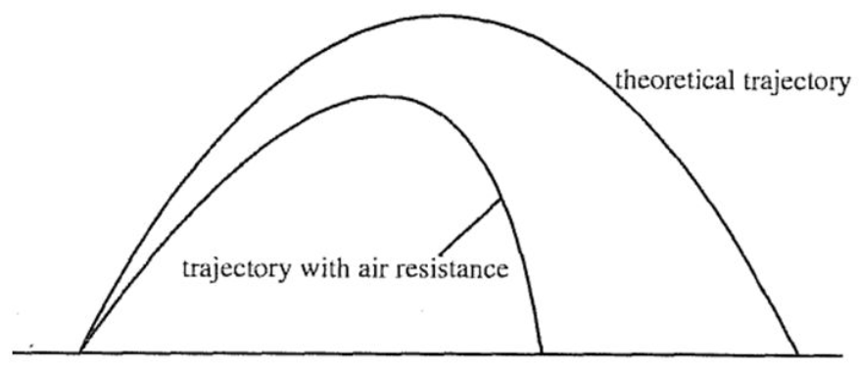

The maximum range will occur for a launch angle of 45° (assuming no air resistance).

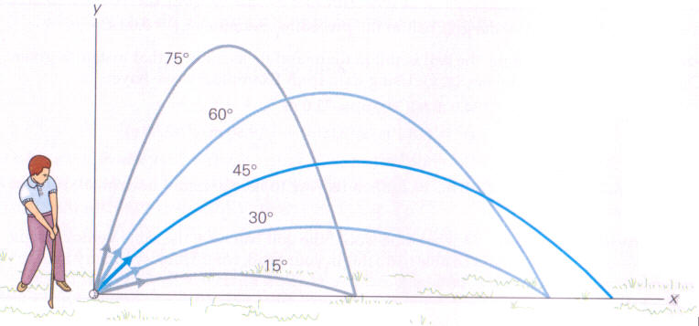

**Set 3**

**Q: If you want to throw a ball as far as is theoretically possible, the best angle to throw it is 45° above the horizontal. Explain why this gives the maximum range.**

The launch angle of 45° is a compromise between maximising the vertical and horizontal components of the launch velocity. Increasing the vertical component increases the flight time before landing. Increasing the horizontal component increases the horizontal distance covered while the projectile is in the air. A launch angle of 45° - which only maximises the range when the take-off and landing heights are the same – optimises the interaction between these two quantities. For projectiles in which the landing height is lower than take-off, the range is maximized by using an angle slightly lower than 45°. For landing heights higher than take-off height the range is maximized by using an angle slightly above 45°.

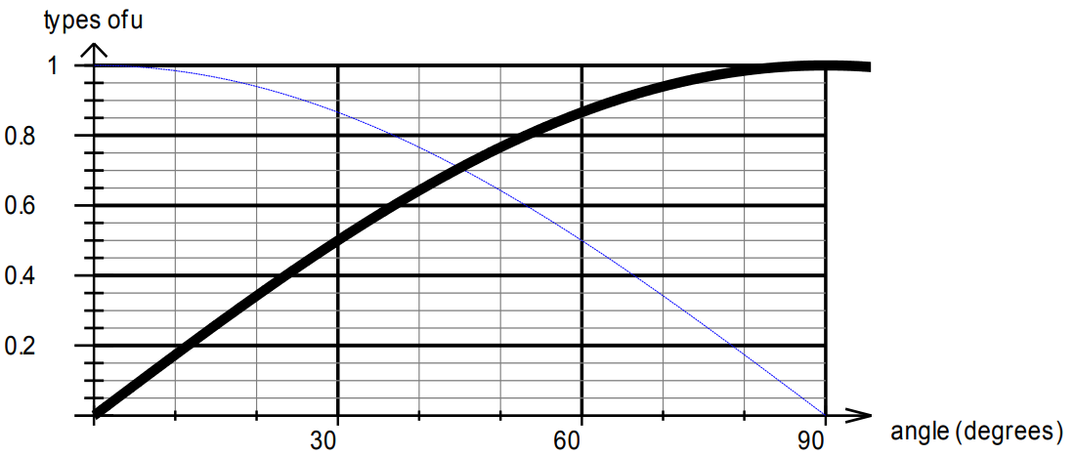

Black line represents uv

Blue line represents uh

45° is where the 2 functions are magnified.

**Q: A fielder on the boundary of a cricket oval returns the ball to the wicketkeeper. Why does the force of gravity not affect the horizontal velocity of the ball?**

If the force of air resistance is ignored, then there is only one force acting on the ball – gravity. The force of gravity (weight) acts vertically downwards towards the ground – it has no horizontal component. Therefore, there is no component of the weight force that can accelerate the ball in a horizontal direction. Hence, if air resistance is ignored, the velocity of the ball in the horizontal plane will be constant.

**Resultant force acting on the ball at each position**:

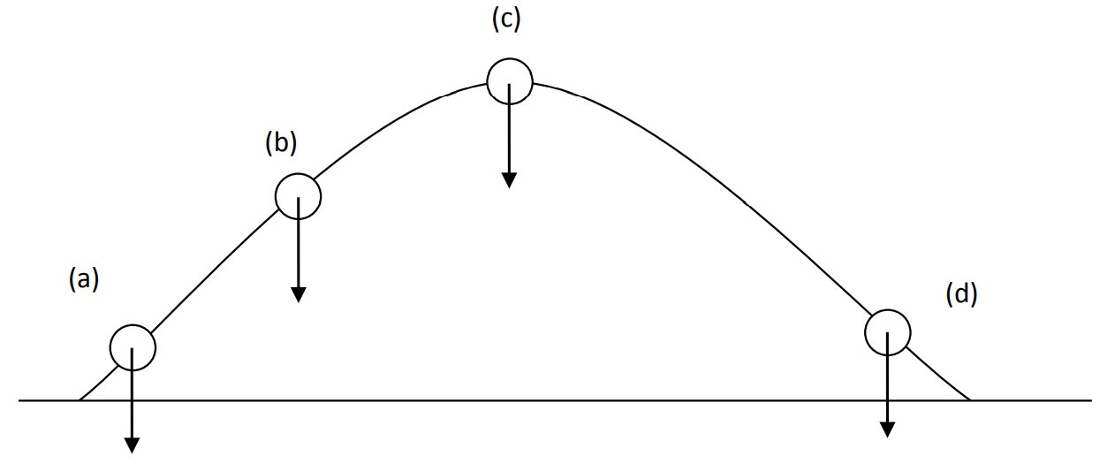

**Vertical, horizontal and resultant velocities at the top, middle and near the bottom of a diver’s path**:

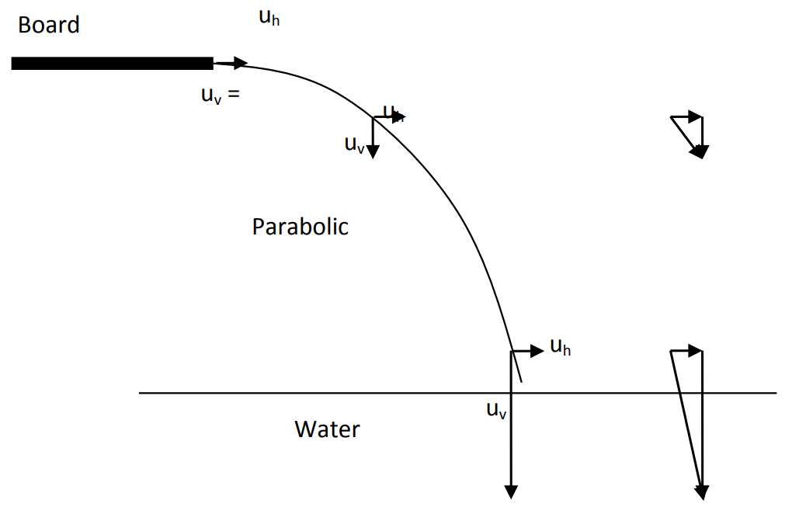

**Q: In a shooting competition, the target is 1000m from the competitors. The shooters set the sights of their rifles so they aim a certain distance above the target. Explain why the bullet still manages to hit the target.**

Throughout its flight, the bullet is accelerated towards the ground by the force of the bullet‘s weight. This causes the bullet to lose height. By aiming above the target, the bullet will follow a parabolic trajectory; the bullet will rise to a maximum height and then fall back to the height at which it will hit the target.

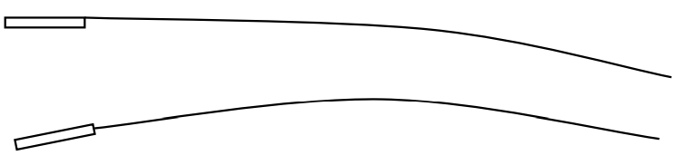

**Q: At a fun fair, you and your friend decide to try your hand at a “knock-em-down” game. The target is a stack of empty cans about 4m away at head height. You have 4 foam rubber balls to use. Your friend tells you to throw the balls as fast as possible. The operator advises you that throwing them more slowly may be better. Explain how each method could successfully knock down the stack of cans.**

|  |  |  |
| --- | --- | --- |
|  | Throw as fast as possible: | Throw slower: |
| Advantages | The force with which the ball hits the tins will be larger and directed horizontally through the cans with only a small component in the vertical. | The air resistance experienced by the balls will be smaller and will be less likely to steer the ball off course, causing it to miss the target. |
| Disadvantages | The air resistance on the ball will be larger due to the increased velocity. This air resistance, if not evenly distributed, will cause the ball to steer off course and slow dramatically. | The force with which the ball hits the cans will be reduced; and the horizontal component of that force will also be smaller because the ball will be on a steeper trajectory downwards when it hits the cans. |

**Q: A student woman I attempting to jump her car across a pair of ramps that are 38m apart. To successfully complete the jump, she must driver her car at a minimum constant speed up the ramp.**

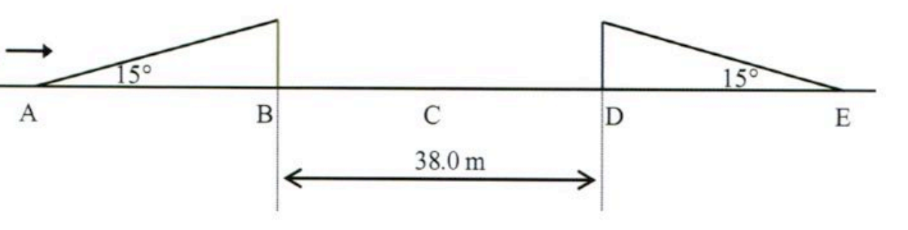

**[a] Will there be a point during the flight of the car where the stunt woman and her car experience zero acceleration? If so where?**

No. During the flight, the car will always be experiencing an acceleration of 9.80 ms-2 vertically downwards due to gravity.

**[b] What will be the velocity of the car at its highest point? Justify your answer.**

At its highest point (maximum height) the velocity will be u cos15 in a horizontal direction. At this point, the vertical component of its velocity is zero. Hence, its velocity will only consist of its original horizontal launch component (if friction is ignored).

**[c] At what point, A, B, C, D or E, in her journey will she have the greatest speed? Why?**

Given that the jump is completed successfully with a minimum speed, we can assume that the car lands at D. There are a few possibilities here:

If air resistance is ignored, then the car will land at D with the same speed as at A and B. If the driver does not apply any brakes when it lands, the car will accelerate down the slope and will experience its greatest speed at E.

If air resistance is NOT ignored, then the car will land at D with a lower speed than at A and B. Again, if the driver does not apply any brakes when it lands, the car will accelerate down the slope and will experience its greatest speed at E.

In both scenarios, minimum velocity will be at C (v = 0 ms-1). There may be other scenarios.

**Q: A cricket batsman is hitting the bowlers all over the ground. One shot that he makes just clears the fence on one part of the ground.**

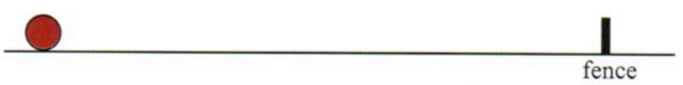

**Sketch, using a solid line, the path the ball follows if it just clears the fence. Ignore air resistance. Also sketch, using a dotted line, the path the ball follows if it just clears the fence, this time taking air resistance into account. Show the forces acting on the ball at its highest point.**

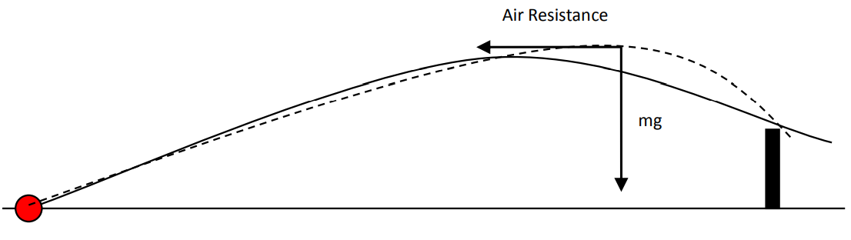

**Q: Very fast sprinters are often also very good at long jump. Explain.**

A long jumper becomes a projectile after they launch themselves. The objective in long jump is to maximise the horizontal displacement achieved by the projectile. Maximising launch speed will help to achieve this objective. The larger the launch speed ‗v‘ for a particular launch angle (θ), the larger the horizontal component of this velocity (v cos θ) – which is maintained at a constant rate throughout the jump (ignoring friction). The horizontal distance achieved by the long jumper can be represented as v cos θ x t (t = flight time). Given sprinters can achieve a higher value for ‗v‘ than other runners, they can achieve a longer jump.